*Data Visualization of Bird Strikes between 2000 – 2011*

*Wireframe document*

*Homepage*

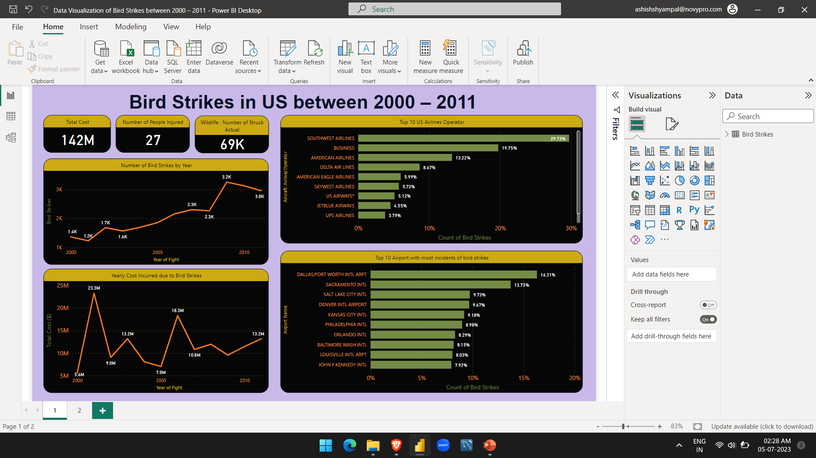

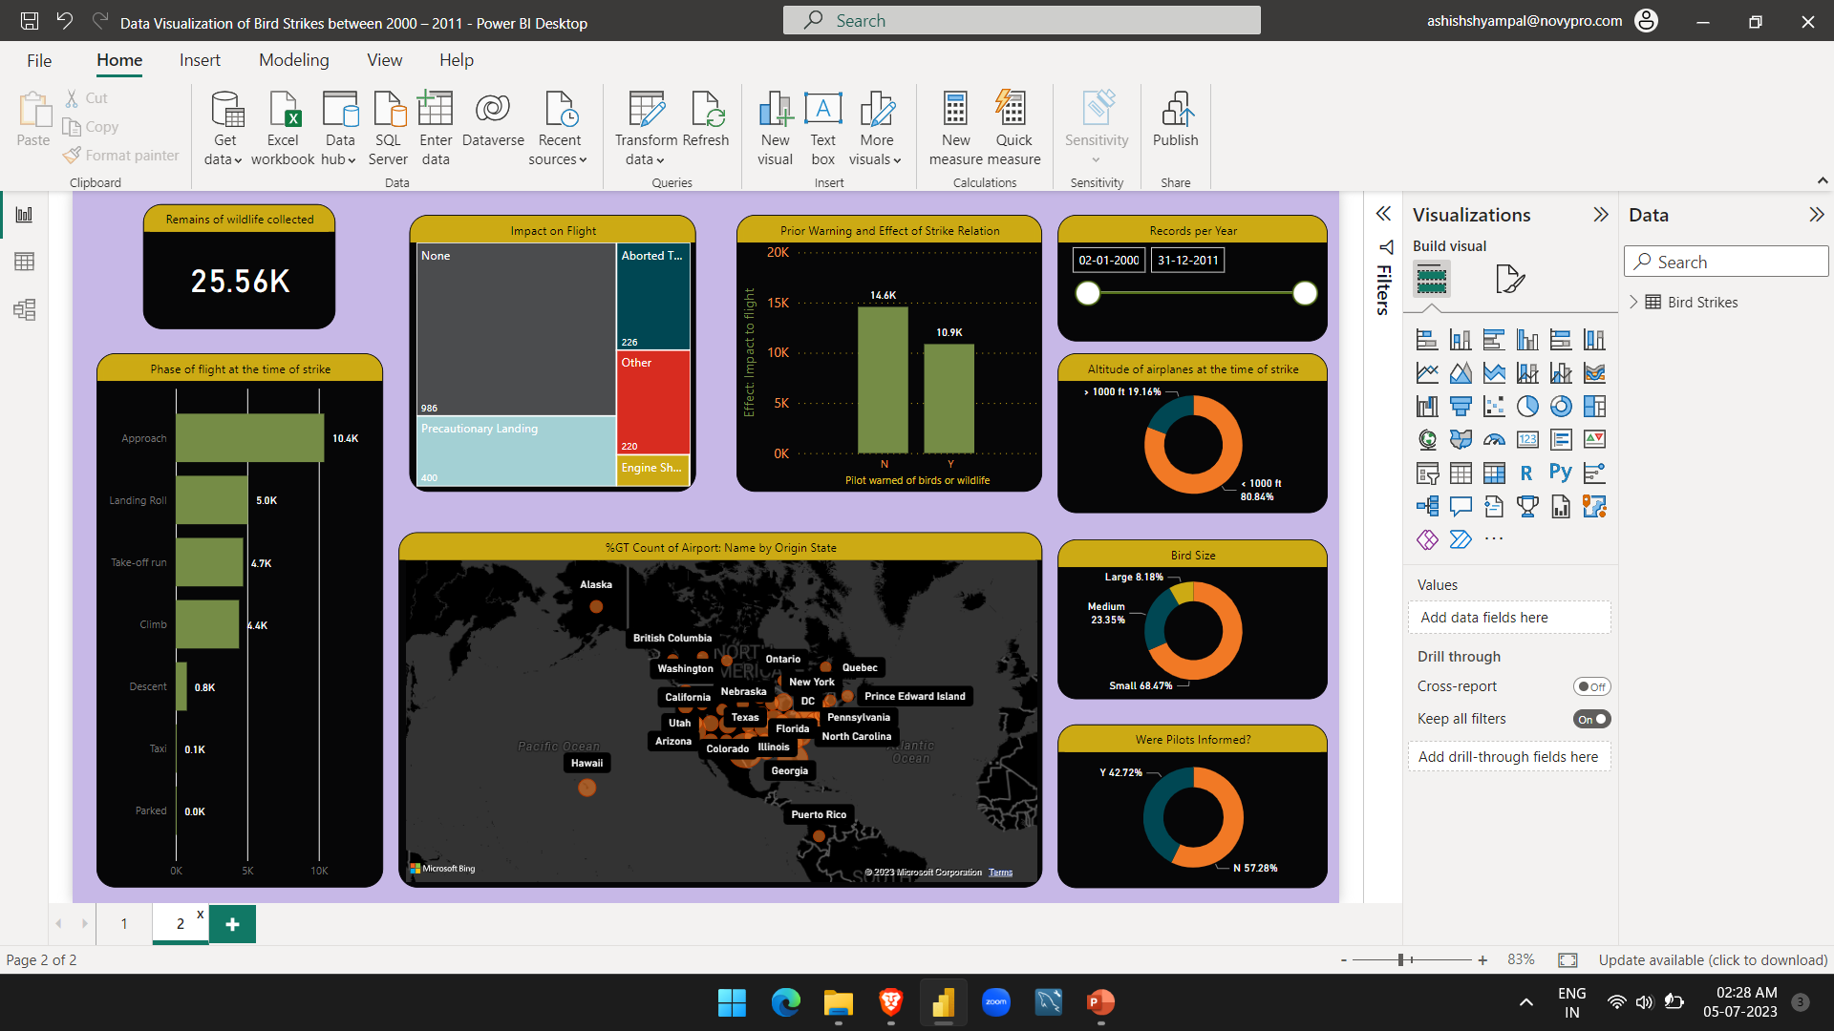

1. Visuals Depicting the Number of Bird Strikes:

1.1 Bird Strikes in US

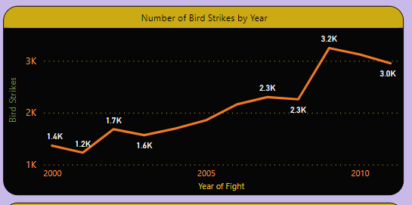

1.2 Top 10 US Airlines in terms of having encountered bird strikes

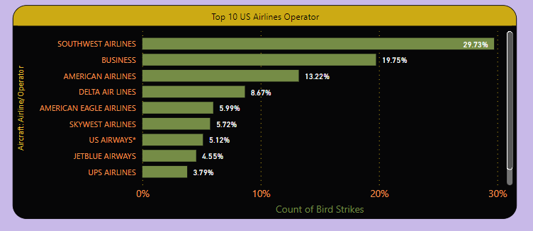

1.3 Airports with most incidents of bird strikes

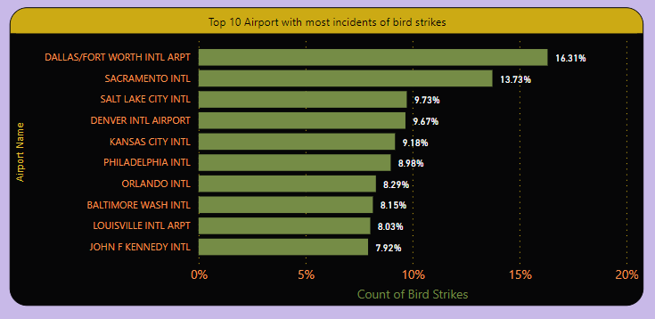

2. Yearly Cost Incurred due to Bird Strikes

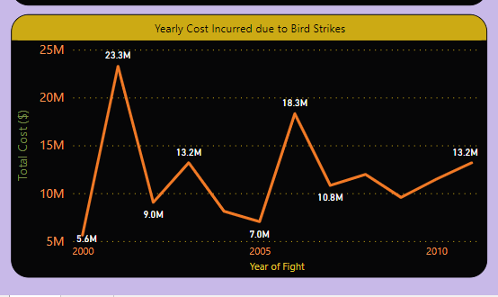

3. When do most bird strikes occur?

3.1 Altitude of airplanes at the time of strike

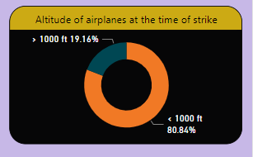

3.2 Phase of flight at the time of strike

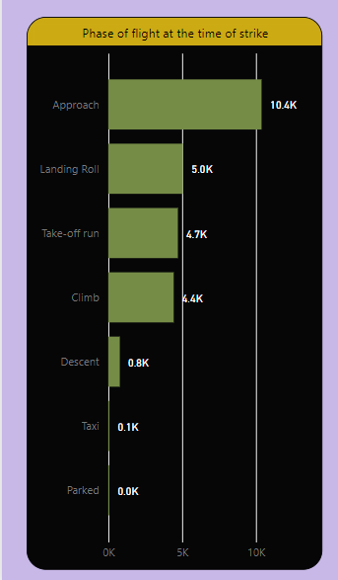

4 Effect of Bird Strike

4.1 Impact on Flight

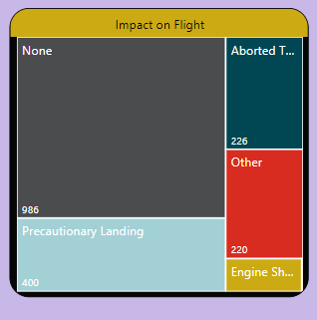

4.2 Were Pilots Informed?

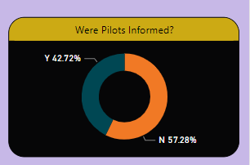

4.3 Prior Warning and Effect of Strike Relation

